**AYDIN ADNAN MENDERES UNIVERSITY**

**ENGINEERING FACULTY  
COMPUTER ENGINEERING DEPARTMENT**



**İoT Based Garden Monitoring System**

**Project Team Info**

Team members:

Emin Hasanzade (171805071)

Muhammet Ali Ilgaz (171805017)

Meve Cavlı (181805083)

**Team Name:**

3 Badam

# About 3Badam Team

We are a three person team that came together for designing and implementing software systems. We believe each other as the team because we have some knowladges about some different things in computers. We thougth these knowledges helps us when we are developing this projects. We are determined people. This is most important for project and project deadline. We think we will have a successful result. Our biggest common feature is that we are always open to learning and development. That is why we are strong together as a team.

# 3Badam Team Members

Emin Hasanzade

(Project Supervisor)

It's hard to describe myself – even harder when I have to speak briefly!😅 I'm a 3D Generalist and one of the founders of Kampot Entertainment with nearly 6 years of experience, I'm from Azerbaijan.

My best thing is positive thinking. My negative side is that I want to do everything with myself, it is from my childhood habit and I get more experience with such things. My hobby is watching movies every night, reading philosophy books, playing games

**Education and Qualitys**

**Spt 2017- ongoing:**

Computer Engineering / Adnan Menderes University, Aydın

-Develop a FPS shooter game for our company

- Develop App for customers and for Our StartUps.

-Devleop Tender app ( like Tinder) it successfully published in Play store and promoted to top #2 in just one week

- I took the first place in the game development competition in Azerbaijan

- Lots of online learning channels certificate

**Spt 2006-June 2017:**

Azerbeycan Baku 20 numaralı okul

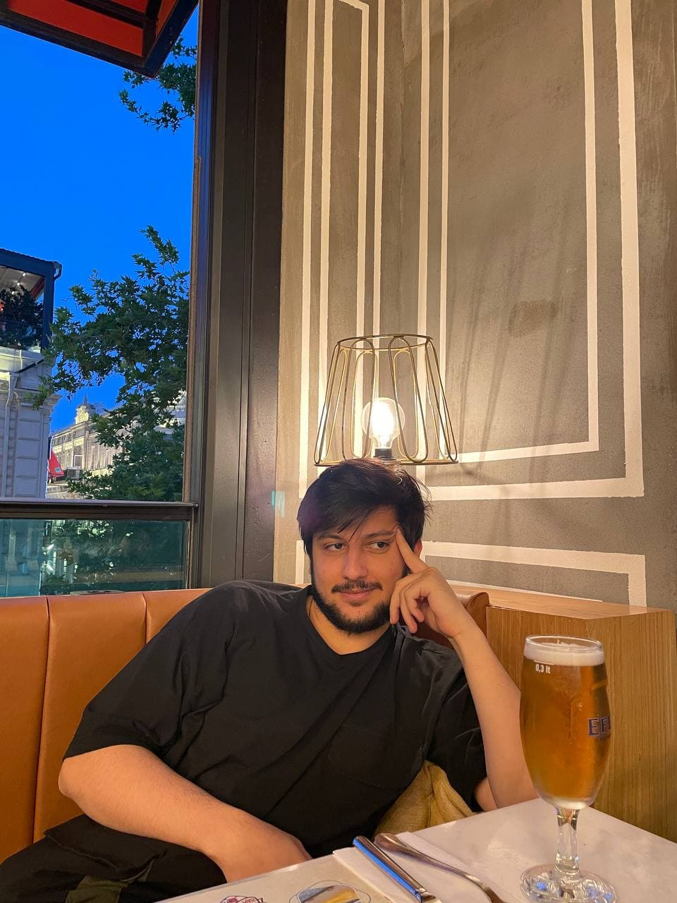

**Skills:**

-Autodesk Maya,

-Autodesk 3Ds Max

-Unreal Engine 4

-Game Developer

-3D generalist

-Arnold Render Engine

- Java

**Languages:**  Azerbaijan,

English,Turkish,Russian

**GitHub account name:** Em1nz4de

Muhammet Ali ILGAZ

I love pushing the limits all the time. Being successful is very important to me. For me, determination, struggle and work are always at the forefront. I like to be the best at what I do. There is no limit to knowledge, and in this context, I attach importance to improving myself at any time.

**Education and Qualitys**

**Spt 2017-June 2022:**

Computer Engineering / Adnan Menderes University, Aydın

-Working as a game developer in Happy Game Jam, Mobile Game Development event.

- Being a pioneer in the team with creative thinking and adapting to teamwork.

-To increase experiences on mobile game development

-Join to BİLMÖK, Bilgisayar Mühendisliği Öğrenci Kongresi (Yeditepe University-2017)

-Being innovative

**Spt 2011-June 2015:**

Hatice Sezer Anadolu Öğretmen Lisesi, Antalya



**Skills:**

-Java,

-C#

-Python

-Game Developer

-Unity

-Android Programming

**Languages:** English,Turkish

**GitHub account name:** ilgazali

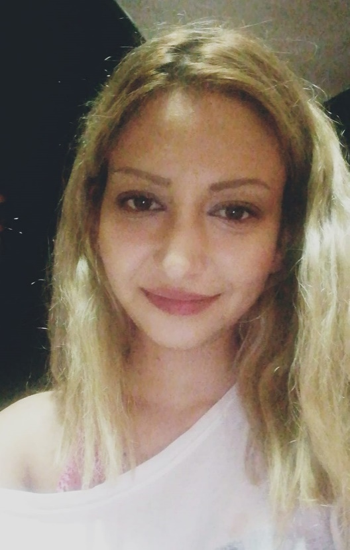

Merve CAVLI

Since i was a child I have always been a curious person. I can say that learning something new is my passion. I have never been a person who improves herself in only one certain field. I am a student of Computer Engineering department for now but I know that i will never be only an engineer. I will be a dancer, an actress, an archer and i can be anything at the same time. Believing myself makes me a successful person all the time. I trust myself, and i can be good at anything.

Education and Qualitys

**Spt 2017-June 2022:**

-Computer Engineering / Adnan Menderes University, Aydın

-Korean Language training from iienstitu.com / received a certificate.

-Championship award from Toros Collage Chess Tournament

-Join to BİLMÖK, Bilgisayar Mühendisliği Öğrenci Kongresi (Yeditepe University-2017)

-Being versatility

**Spt 2013-June 2017:**

İçel Anadolu Lisesi, Mersin

**Skills:**

-Java,

-C

-Python

-HTML5

-CSS3

**Languages:**

English,Turkish,Korean Language

**GitHub account name:** mervecavli

# Team Agreement

* All group members will attend main meetings via Google Meet but in case of a need, any other means of communication can be used.
* Meetings will be held face-to-face and online.
* Each team member should return to messages or calls sent to them in a timely manner.
* There will be a main meeting every two days and attendance is mandatory.
* Each team member will present a status report at the meetings.
* Each team member will take jobs according to their interests and skills, and one person will be elected team leader by voting, and the selected person will be responsible for the distribution of tasks.
* Team members will submit their assigments at each meeting and the team leader will review them.
* If any team member is ineffective, the team member will be warned by the team leader and the other team members will take care of the disrupted work among themselves.
* Assignment submitting done by Supervisor.
* İf one of the team member drops out, then we will re-group and we should review the sprint